Classification II

Report

Machine learning and Data mining II

Nguyễn Mạnh Hưng - 22BI13183

Nguyễn Trọng Minh - 22BI13304

**TABLE OF CONTENT**

1. **Decision Tree**
2. Analyze the dataset
3. Decision tree
4. Error calculation
5. **Random Forest**
6. Analyze the dataset
7. Random forest
8. Comparison

1. **Decision Tree**
2. **Analyze the dataset**

In this lab work, we chose 2 data sets both that are well-classified. The first data is used to predict whether one individual has heart problem or not. This data set is binary classified.



Data about heart disease

The other one is about predicting weather with 4 features, divided into 5 weather types.



Data about weather

Both data sets are well-maintained so we actually do not need to clean the data much. We drop only data column in weather data set since it is just a time stamp. After that, we split data into training and testing set with 8-2 ratio.

If we take a look at the 2D plotted data, we can see that they are completely mess, and we can not apply any linear classification. This is a good case of using tree classification.

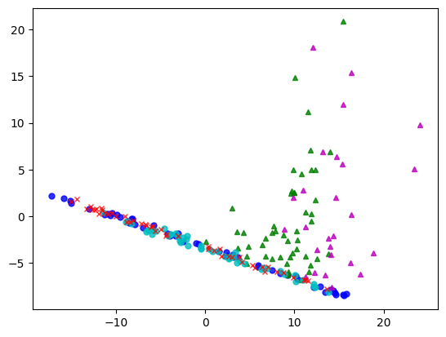

**2D graph of weather dataset**

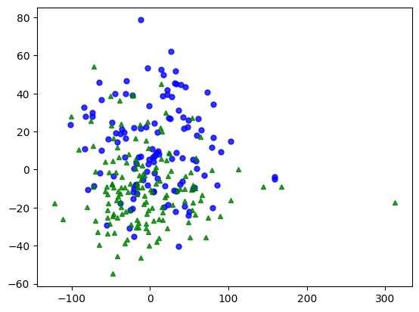

**2D graph of heart disease dataset**

1. **Decision tree**

We start making tree with sklearn module. There are 3 criterions we can choose: Gini loss, entropy and log loss. Basically, entropy and log loss are the same, so we use entropy formular as our criterion to determine which value to split data into.

For the weather data, we came up with the root case is if precipitation is smaller than 0.15, since most of this feature is 0. After all, we got a tree with depth of 24 layers, and there are 222 leaves nodes.

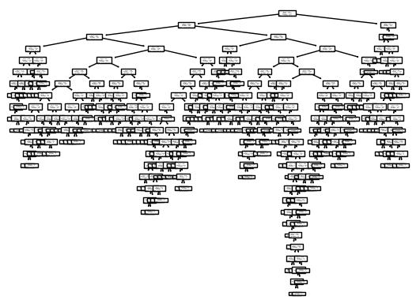

**Tree graph of weather data classification**

With the heart disease data, there are much less data points, so that we got a smaller tree than the one above. The root case in this data set is if thallium level of patient is less than 4.5. At the end, we got a tree with depth of 8 layers and 37 leaves nodes.

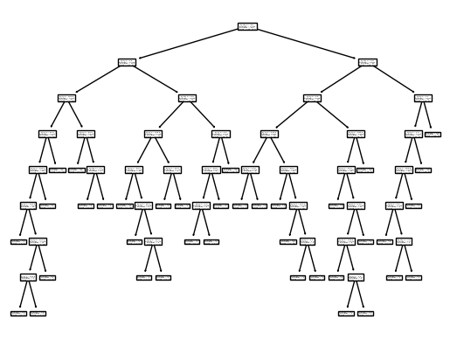

**Tree graph of heart diseases data classification**

1. **Error calculation**

To validate our tree classifier model, we can take a look at accuracy by compare predicted labels with true labels in testing data. This is a common way to check the error in supervised learning.

Fortunately, both of our models have quite a good result in prediction. The weather tree classifier has mean accuracy of 70,2% with the following confusion matrix.

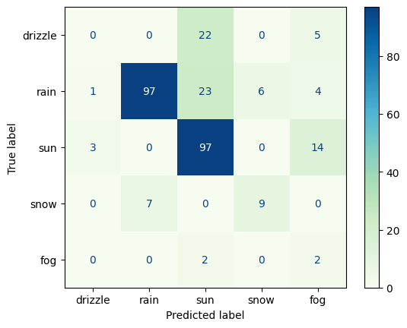

**Confusion matrix of weather prediction**

We notice that most of the correctly predicted are rain and sun categories. This is because the majority of the data set are rain and sun categories, which led to poor accuracy in the rest of the data set.

          On the other hand, the heart diseases data set contains only 2 categories and is more equally distributed (120 of absence and 150 of presence), it got a better accuracy of 81.5% mean accuracy. 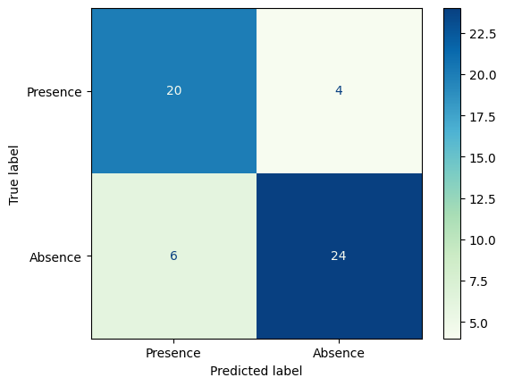

**Confusion matrix of heart disease prediction**

**II. Random Forest**

**1. Analyze the data**

For the second part, we still chose the same datasets as the previous part, which are the weather dataset with the classification of 5 types of weather and the heart diseases dataset to predict whether a person has heart diseases or not.

**2. Random Forest**

Before starting to train the model, we used cross-validation to create 100 training sets with Kfold and 1 testing set. Here, we chose 20% of the dataset will be the testing set.

          We start making the Random Forest model. First of all, we built 100 Random Forest models with 100 trees and used the entropy formular as the criterion, then we started to train each of them with each training set. The next step is that we use the testing set to calculate the error of each Random Forest model by taking 1 minus the accuracy score of each model and putting it into a list called “Errors”. Finally, we convert the list into an array and calculate the mean error of the model.

*For the weather dataset: the mean error calculated is 18.17%

*For the heart disease dataset: the mean error calculated is 15.5%

**3. Compare the results**

Regarding the weather dataset, we can see that the accuracy of the Decision Tree on the training set is 70.2% which means that the error calculated is 29.8% while the Random Forest model has the error calculated as 18.17%. As a result, we can see that the Random Forest works more efficiently in classifying the dataset.

          About the heart disease dataset, the accuracy of the Decision tree is 81.5% and the accuracy of the Random Forest is 84.5%, which means that the Random Forest model still works more efficiently in classifying the dataset. 